Chapter 4, Solution 89

It is easy to solve this problem using Pspice.

(a) The schematic is shown below. We insert IPROBE to measure the desired ammeter reading. We insert a very small resistance in series IPROBE to avoid problem. After the circuit is saved and simulated, the current is displaced on IPROBE as .

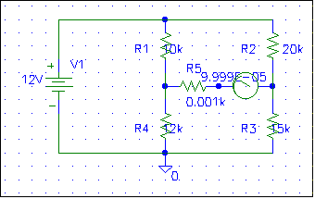

(b) By interchanging the ammeter and the 12-V voltage source, the schematic is shown below. We obtain exactly the same result as in part (a).

